Seller Cure Election — Transmittal
Case reference: EXC-24017. Contract reference: REC-2024-017.
The seller returned one signed election form through the designated settlement channel. The controlling selection and receipt marks appear only on the attached scan.
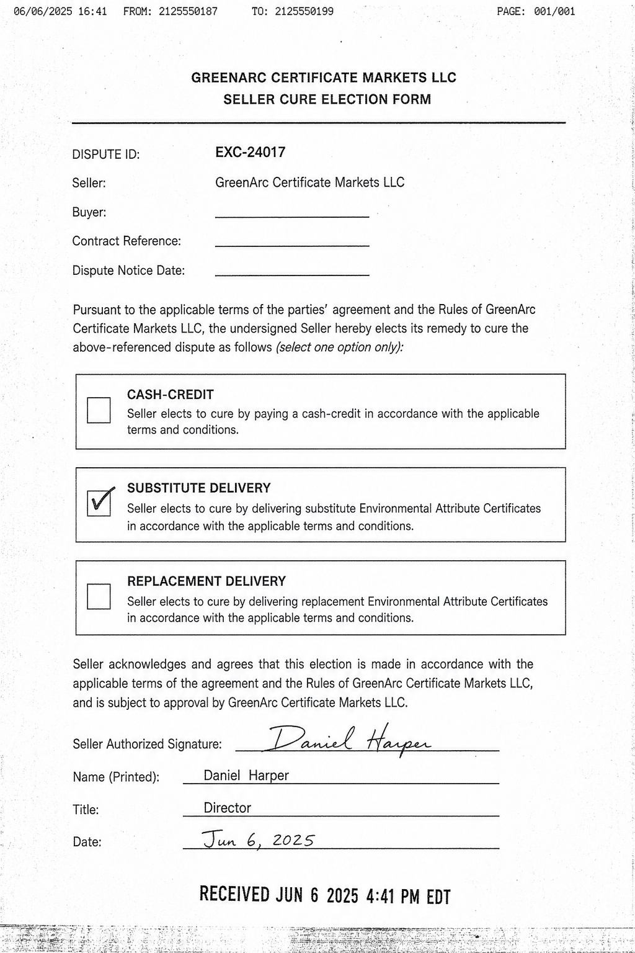
Settlement Operations intake copy. Outcome fields intentionally remain open pending certificate validation.

